Design Review

Date: November 12, 2013

Author: Fanxing Meng

Reviewer(s): Jayaprakash Ganta

# Original Design

(Next page)

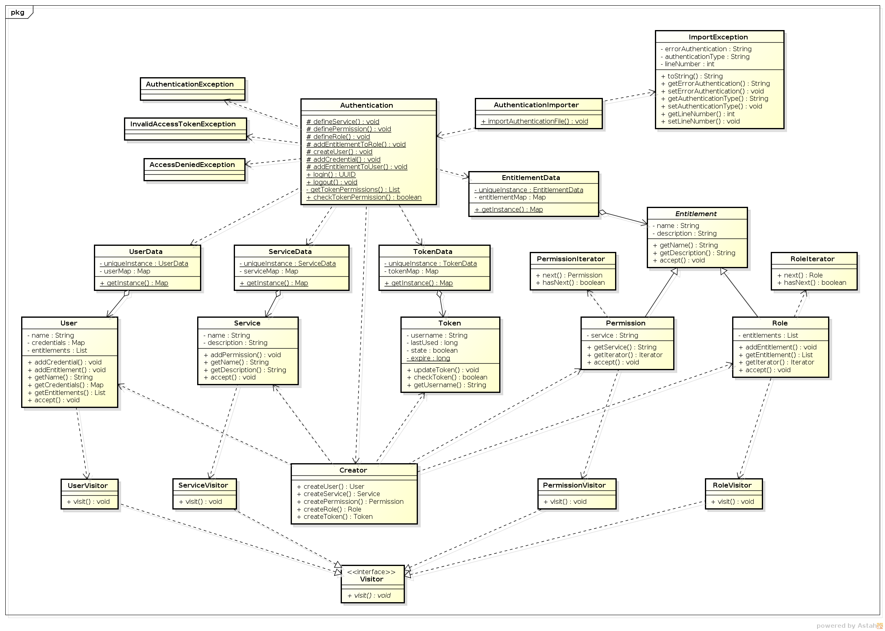

# Comments

1. Object ID’s should also be included in each object’s class
2. Visitor does not have to be matched to each different class
3. There’s no function for changing a password, which is especially important for the admin user
4. Using hash code to store password is unsecure as collision chances are high
5. The authentication class is not using singleton pattern
6. Should incorporate interactive user interface for logging in/out and importing files

# Changes

1. Added ID field in User, Service, Token, and Entitlement classes
2. Changed redundant concrete visitors into a single PrintVisitor class
3. Added a changePassword function in Authentication class
4. Incorporated an MD5 converter function to compute MD5 sum from string
5. Converted all static methods in Authentication class to act upon a singleton instance of Authentication object
6. Got rid of some unused functions in ImportException
7. Added a map in Role class to temporarily store all child members contained in this role to get the iterator working
8. Changed getInstance methods in UserData, ServiceData, and EntitlementData classes to return the instance of the class instead of the map, and created getMap function to return the map to allow for accepting visitor on all map entries

(Result on next page)

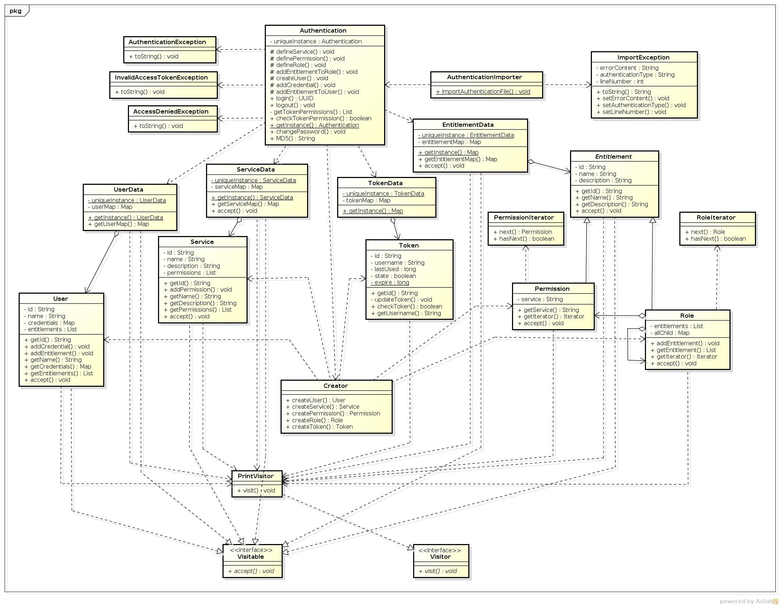

# Summary

The document benefited the skeleton of the initial phase of implementation, however there are still certain flaws that created bugs during first testing, including incorrectly assigned iterators.

If the requirement of using visitor pattern and singleton pattern could be relaxed, much of the UserData, ServiceData, EntitlementData manipulation can be put inside the Authentication class and simplify the logic. The factory pattern did not provide any advantage in this phase of work since none of the 5 classes share identical constructor parameters.

The review process revealed some flaws in the original design, such as missing functionalities and overlooked security issues. The review also hinted on some pattern implementation misunderstandings hidden in the original design that needs rework.